# Name :- Sarthak Pagar

# Roll No. :- 40

# Class :- TE(IT)

# Practical 7B :- Perform the following data visualization operations using Tableau on Iris datasets.

a. 1D (Linear) Data visualization

b. 2D (Planar) Data Visualization

c. 3D (Volumetric) Data Visualization

d. Temporal Data Visualization

e. Multidimensional Data Visualization

f. Tree/ Hierarchical Data visualization

g. Network Data visualization

a.

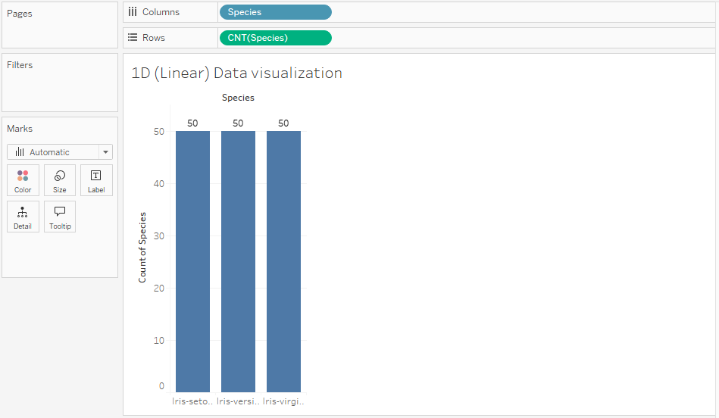

b.

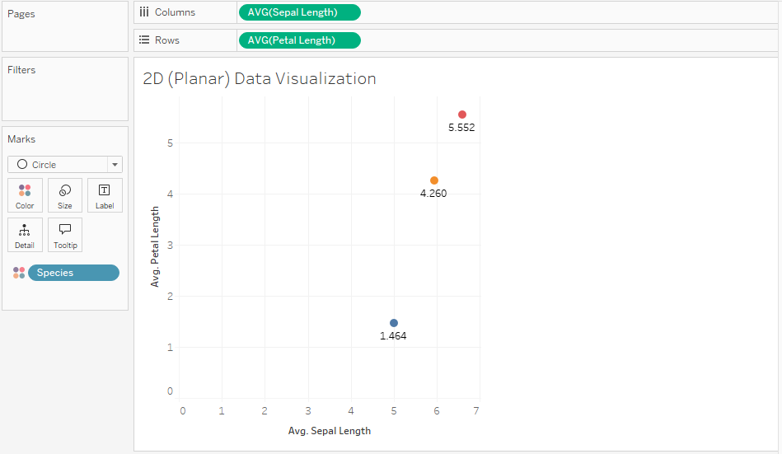

c.

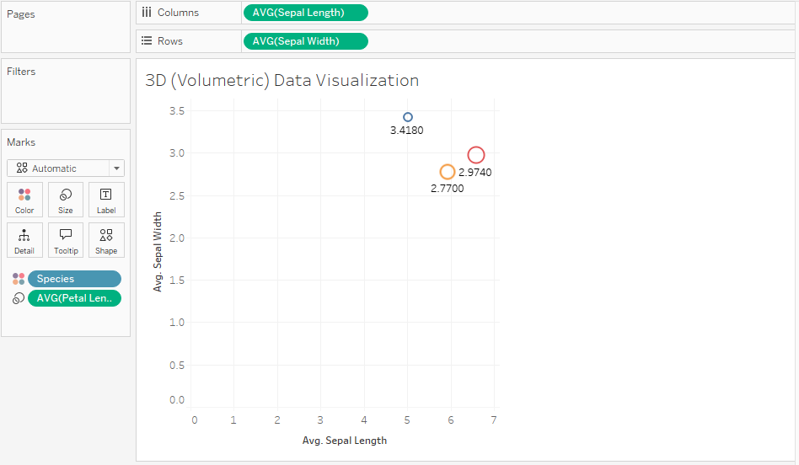

For d, there is no time related data. So, we used create bins on sepalLength with bin size 0.5 and named it as “Time Period”.

d.

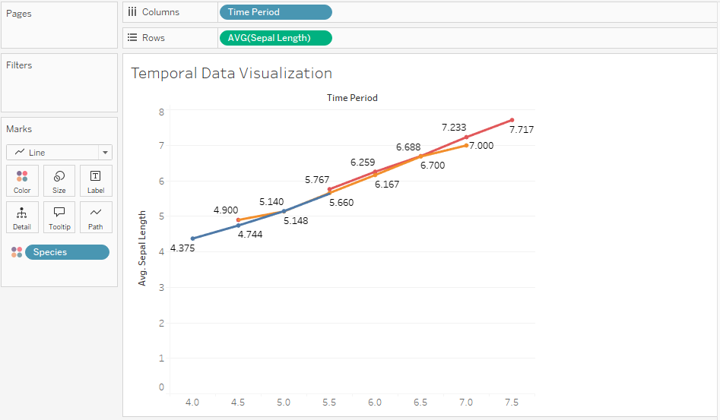

e.

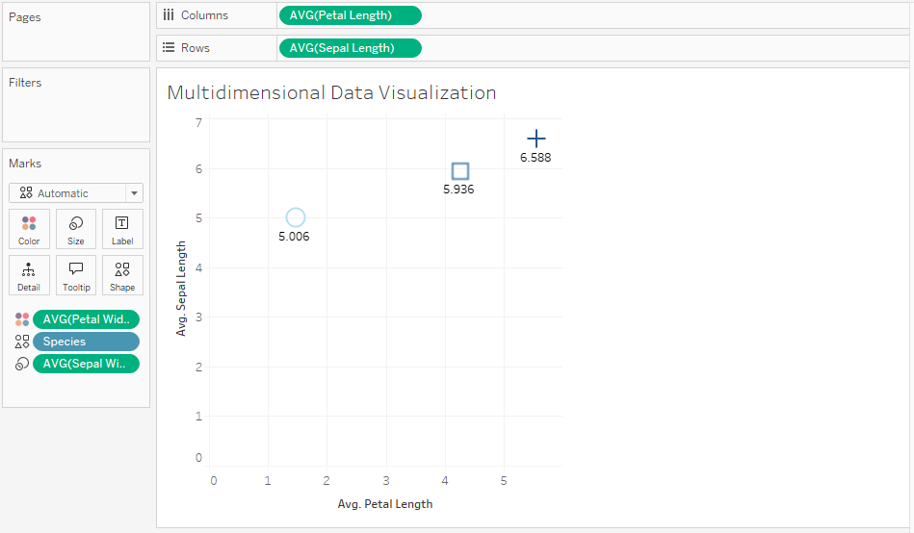

f.

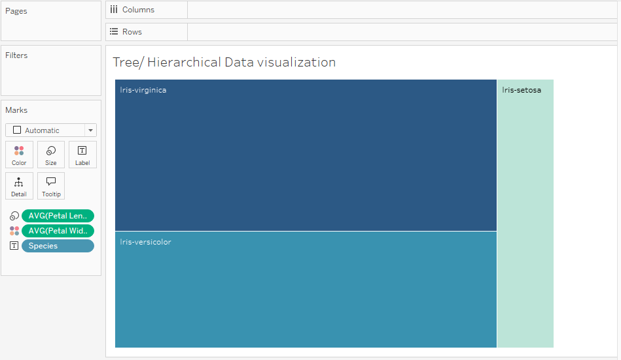

For g, we have used external extension “Network”.

g.

